Shows the program response to bad input, as well as the first Fibonacci number (edge case of 1).  
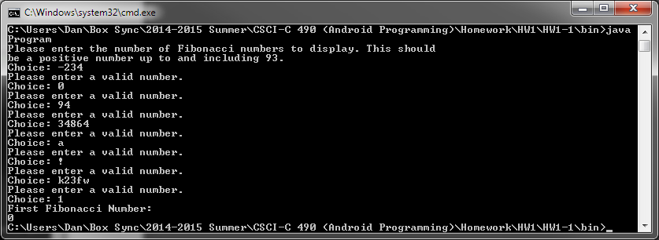

Shows “normal choice of 2.  
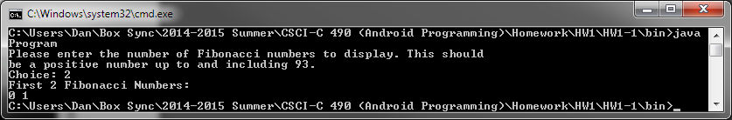

Shows “normal” choice of 10.  
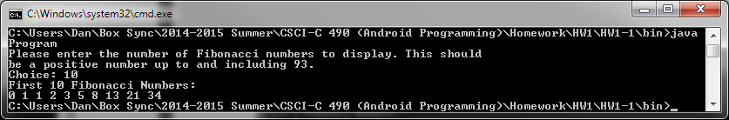

Shows the edge case of 93.  
